**IoASU** (**Innovation on ASU**)

Team Entrepreneurs

Ishwar Bhat Kattur

Anirban Bhattacharya

Dhivya Raja

Priyanka Pakhale

Arizona State University

Prof. Usha Jagannathan

IFT530

05/01/2017

**Introduction**

Student engagement is a vital aspect of academic life and organizations on campus ensure meaningful involvement outside the curriculum. Our project IoASU aims at involving and engaging the students with their organizations, by providing a mobile application for the users as well as the admins, to interact with their organizations.

1. DDL (Data Definition Language)

The following is the create table statements for IoASU.

USE master;

GO

IF DB_ID('IoASU') IS NOT NULL

DROP DATABASE IoASU;

GO

CREATE DATABASE IoASU;

GO

USE IoASU;

-- create the tables for the database

CREATE TABLE Campuses (

CampusID INT PRIMARY KEY IDENTITY,

CampusName VARCHAR(255) NOT NULL,

Location VARCHAR(255) NOT NULL,

);

CREATE TABLE Organizations (

OrgID INT PRIMARY KEY IDENTITY,

Name VARCHAR(255) NOT NULL,

Email VARCHAR(255) NOT NULL,

Phone VARCHAR(10),

MeetingVenue VARCHAR(255),

WeeklyMeetDay VARCHAR(10),

WeeklyMeetTime TIME,

WebLink VARCHAR(255),

DateOfCreation DATETIME DEFAULT GETDATE()

);

CREATE TABLE CampusOrganization (

CampusID INT REFERENCES Campuses (CampusID) NOT NULL,

OrgID INT REFERENCES Organizations (OrgID) NOT NULL,

PRIMARY KEY (CampusID, OrgID)

);

CREATE TABLE Departments (

DepID INT PRIMARY KEY IDENTITY,

Department VARCHAR(255)

);

CREATE TABLE Users (

UserID INT PRIMARY KEY IDENTITY,

ASUID VARCHAR(20),

Password VARCHAR(128) NOT NULL,

PasswordSalt VARCHAR(128),

LName VARCHAR(255) NOT NULL,

FName VARCHAR(255) NOT NULL,

Bio VARCHAR(255)

);

CREATE TABLE UserPhones (

UserID INT REFERENCES Users (UserID) NOT NULL,

Phone VARCHAR(10) NOT NULL,

PRIMARY KEY (UserID, Phone)

);

CREATE TABLE UserEmails (

UserID INT REFERENCES Users (UserID) NOT NULL,

Email VARCHAR(255) NOT NULL,

PRIMARY KEY (UserID, Email)

);

CREATE TABLE UserDepartment (

UserID INT REFERENCES Users (UserID) NOT NULL,

DepID INT REFERENCES Departments (DepID) NOT NULL,

PRIMARY KEY (UserID, DepID)

);

CREATE TABLE UserOrganization (

UserID INT REFERENCES Users (UserID) NOT NULL,

OrgID INT REFERENCES Organizations (OrgID) NOT NULL,

Status VARCHAR(25) NOT NULL,

PRIMARY KEY (UserID, OrgID)

);

CREATE TABLE Events (

EventID INT PRIMARY KEY IDENTITY,

EventName VARCHAR(255) NOT NULL,

EventDesc VARCHAR(255),

Time DATETIME,

Venue VARCHAR(255),

LinkToJoin VARCHAR(255)

);

CREATE TABLE EventOrganization (

EventID INT REFERENCES Events (EventID) NOT NULL,

OrgID INT REFERENCES Organizations (OrgID) NOT NULL,

PRIMARY KEY (EventID, OrgID)

);

CREATE TABLE Categories (

CategoryID INT PRIMARY KEY IDENTITY,

CategoryName VARCHAR(255) NOT NULL,

);

CREATE TABLE CategoryOrganization (

CategoryID INT REFERENCES Categories (CategoryID) NOT NULL,

OrgID INT REFERENCES Organizations (OrgID) NOT NULL,

PRIMARY KEY (CategoryID, OrgID)

);

CREATE TABLE Documents (

DocID INT PRIMARY KEY IDENTITY,

DocName VARCHAR(255),

DocDesc VARCHAR(255),

DocLink VARCHAR(255) NOT NULL

);

CREATE TABLE DocumentOrganization (

DocID INT REFERENCES Documents (DocID) NOT NULL,

OrgID INT REFERENCES Organizations (OrgID) NOT NULL,

PRIMARY KEY (DocID, OrgID)

);

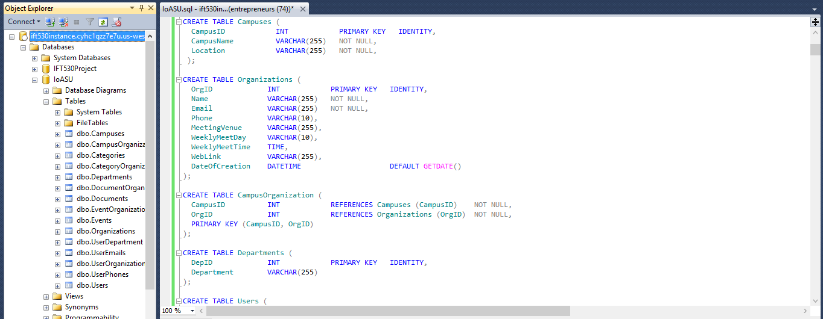

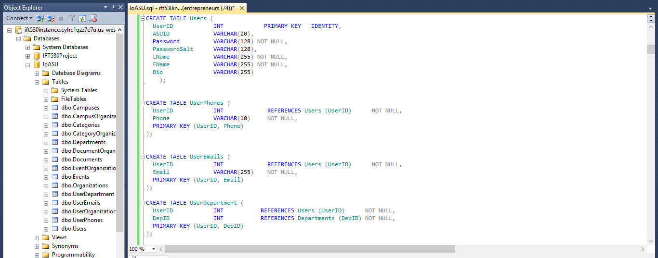

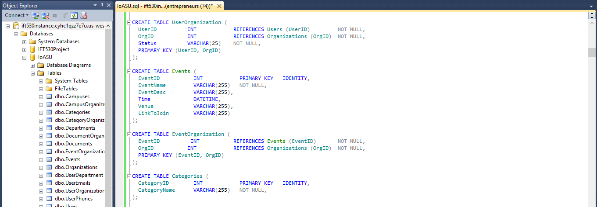

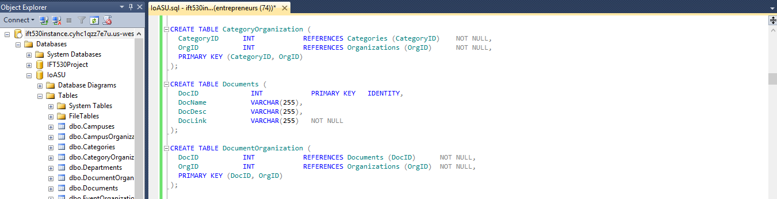

2. Data Insertion:

SET IDENTITY_INSERT Campuses ON;

INSERT INTO Campuses (CampusID, CampusName, Location) VALUES

(1, 'Tempe', 'Tempe'),

(2, 'Downtown', 'Phoenix'),

(3, 'Polytechnic','Mesa'),

(4, 'West', 'Glendale'),

(5, 'Lake Havasu City', 'Lake Havasu'),

(6, 'Thunderbird', 'Thunderbird');

SET IDENTITY_INSERT Campuses OFF;

SET IDENTITY_INSERT Organizations ON;

INSERT INTO Organizations (OrgID, Name, Email, Phone, MeetingVenue, WeeklyMeetDay, WeeklyMeetTime, WebLink, DateOfCreation) VALUES

(1, 'Action for America', 'aofa@asu.edu', '4806567865', 'COWDN', 'Monday', '17:00', 'aofa.org', '2012-04-01'),

(2, 'Active Minds at Arizona State University', 'aminds@asu.edu', '4805782052', 'Art', 'Friday', '16:00', 'aminds.com', '2013-05-23'),

(3, 'Adworks', 'adworks@asu.edu', '4801234357', 'ECE', 'Tuesday', '17:00', 'adworks.com', '2011-01-21'),

(4, 'Aerospace Innovation Club', 'aeroinnoclub@asu.edu', '4806723451', 'Physical Sciences', 'Monday', '19:00', 'aeroinnoclub.org', '2015-03-20'),

(5, 'Alpha Chi Omega Sorority', 'alphachiomega@asu.edu', '4803481228', 'Alpha Chi Omega', 'Thursday', '17:00', 'alphachiomega.com', '2014-02-28'),

(6, 'Barrett Leadership and Service Team', 'barrettLST@asu.edu', '4805987937', 'Barrett Honors College', 'Wednesday', '18:00', 'barrettlst.org', '2010-07-11'),

(7, 'Bhakti Yoga Club', 'bhaktiyoga@asu.edu', '4802651298', 'CPCOM', 'Monday', '17:00', 'bhaktiyoga.com', '2010-08-12'),

(8, 'bioSyntagma', 'biosyntagma@asu.edu', '4805640099', 'Hassayampa Academic Village', 'Wednesday', '19:00', 'biosyntagma.org', '2012-11-23'),

(9, 'Global Business Association', 'gba@asu.edu', '4807763452', 'W P Carey', 'Friday', '16:00', 'gba.org', '2013-09-27'),

(10,'JOYS', 'joys@asu.edu', '4807867654', 'Discovery', 'Thursday', '16:00', 'joys.com', '2014-10-10'),

(11,'Alpha Chi Omega Sorority', 'alchios@asu.edu', '4532549872', 'Peralta', 'Thursday', '17:00', 'alchios.com', '2015-03-10'),

(12,'ASU Club Golf Team', 'golf@asu.edu', '2094567845', 'CPCOM', 'Monday', '17:50', 'asugolf.com', '2014-01-19'),

(13,'Bakers at ASU', 'bakers@asu.edu', '6024549234', 'BAC', 'Friday', '16:00', 'asubakers.com', '2013-04-05'),

(14,'Sustaninable Engergy Solutions', 'energy@asu.edu', '4328766123', 'SanTan Hall', 'Thursday', '16:00', 'joys.com', '2014-10-10'),

(15,'TECH Devils', 'techdevils@asu.edu', '3349877823', 'Fulton Center', 'Wednesday', '16:50', 'techdevils.com', '2013-11-01');

SET IDENTITY_INSERT Organizations OFF;

INSERT INTO CampusOrganization (CampusID, OrgID) VALUES

(1, 1),

(2, 2),

(3, 3),

(4, 4),

(1, 5),

(2, 6),

(3, 7),

(4, 8),

(1, 9),

(2, 10),

(5,11),

(4, 12),

(6, 13),

(5, 14),

(6, 15);

SET IDENTITY_INSERT Departments ON;

INSERT INTO Departments (DepID, Department) VALUES

(100, 'Information Technology'),

(200, 'Civil Engineering'),

(300, 'Biomedical Engineering'),

(400, 'Biodesign Engineering'),

(500, 'Computer Science'),

(600, 'Graphic Information Technology'),

(700, 'Accounting'),

(800, 'Law'),

(900, 'Software Engineering'),

(1000, 'Business Administration');

SET IDENTITY_INSERT Departments OFF;

SET IDENTITY_INSERT Users ON;

INSERT INTO Users (UserID, ASUID, Password, PasswordSalt, LName, FName, Bio) VALUES

(1, 'pbuffet', 'January01@', NULL, 'Buffet', 'Pheobe', 'Information Technology Student'),

(2, 'kclarkson', 'February8', NULL, 'Clarkson', 'Kelly', 'Civil Engineering Student'),

(3, 'bpitt', 'March123@', NULL, 'Pitt', 'Brad', 'Biomedical Student'),

(4, 'jlawrence', 'April09%', NULL, 'Tribianni', 'Joseph', 'Biodesign Student'),

(5, 'jtribianni', 'June123@', NULL, 'Buffet', 'Pheobe', 'Computer Science Student'),

(6, 'cbing', 'Flower##', NULL, 'Bing', 'Chandler', 'Graphic Information technology Student'),

(7, 'rgeller', 'September9@', NULL, 'Geller', 'Ross', 'Law Student'),

(8, 'rgreen', 'August!120', NULL, 'Green', 'Rachel', 'Accounting Student'),

(9, 'mgeller', 'December%2', NULL, 'Geller', 'Monica', 'Software Engineering Student'),

(10,'omunn', 'october003!', NULL, 'Munn', 'Olivia', 'Real Estate Student'),

(11,'mkohl', 'purple365@', NULL, 'Kohl', 'Melissa', ' Dance Student'),

(12,'arigby', 'tesla07!&', NULL, 'Rigby', 'Adam', 'Digital Culture Student'),

(13,'ajolie', 'pitt760!&&', NULL, 'Jolie', 'Angelina', 'Industrial Design Student'),

(14,'cphelps', 'summer2654', NULL, 'Phelps', 'Chase', 'Music Student'),

(15,'kperry', 'paris085!', NULL, 'Perry', 'katy', 'Theatre Student'),

(16,'jtimberlake', 'tennesse653', NULL, 'Timberlake', 'Justin', 'Visual Communication Student'),

(17,'jparsons', 'winter34!&', NULL, 'Parsons', 'Jim', 'Construction Management Student'),

(18,'tcruise', 'topgun&&', NULL, 'Cruise', 'Tom', 'Environmental Technology Management Student'),

(19,'ldicaprio', 'titanic58!', NULL, 'DiCaprio', 'Leonardo', 'Software Engineering Student'),

(20,'hjackman', 'wolverine34!&', NULL, 'Jackman', 'Hugh', 'Information Technology Student'),

(21,'sjohansson', 'lucy986@!', NULL, 'Johansson', 'Scarlett', 'Information Technology Student'),

(22,'mstreep', 'mamamia978!', NULL, 'Streep', 'Meryl', 'Civil Engineering Student'),

(23,'nportman', 'blackswan234!', NULL, 'Portman', 'Natalie', 'Biomedical Student'),

(24,'mmccarthy', 'spy000!', NULL, 'McCarthy', 'Melissa', 'Biodesign Student'),

(25,'mfox', 'jonahhex6567!', NULL, 'Fox', 'Megan', 'Computer Science Student'),

(26,'khudson', 'Bridewars111!', NULL, 'Hudson', 'kate', 'Graphic Information technology Student'),

(27,'mdamon', 'departed986!', NULL, 'Damon', 'Matt', 'Law Student'),

(28,'thanks', 'Sully*@@12!', NULL, 'Hanks', 'Tom', 'Accounting Student'),

(29,'cbale', 'americanhustle5&&', NULL, 'Bale', 'Christian', 'Dance Student'),

(30,'jdepp', 'pirates876!', NULL, 'Depp', 'Johnny', 'Theatre Student');

SET IDENTITY_INSERT Users OFF;

INSERT INTO UserPhones (UserID, Phone) VALUES

(1, '4806742876'),

(2, '6027321879'),

(3, '5204372595'),

(4, '6020981235'),

(5, '5201256822'),

(6, '4803346543'),

(7, '4805572397'),

(8, '6022347654'),

(9, '4809124531'),

(10, '5203228767'),

(11, '4800734576'),

(12, '6024768769'),

(13, '5202343222'),

(14, '6022343424'),

(15, '5202333234'),

(16, '4800999221'),

(17, '4809800094'),

(18, '6024200975'),

(19, '4804522334'),

(20, '5208676668'),

(21, '4803342344'),

(22, '4562345524'),

(23, '5264563454'),

(24, '7865443322'),

(25, '4524565652'),

(26, '2454623444'),

(27, '6556322097'),

(28, '3452409424'),

(29, '2234875009'),

(30, '2230975234');

INSERT INTO UserEmails(UserID, Email) VALUES

(1, 'pbuffet@asu.edu'),

(2, 'kclarkson@asu.edu'),

(3, 'bpitt@asu.edu'),

(4, 'jlawrence@asu.edu'),

(5, 'jtribianni@asu.edu'),

(6, 'cbing@asu.edu'),

(7, 'rgeller@asu.edu'),

(8, 'rgreen@asu.edu'),

(9, 'mgeller@asu.edu'),

(10, 'omunn@asu.edu'),

(11, 'mkohl@asu.edu'),

(12, 'arigby@asu.edu'),

(13, 'ajolie@asu.edu'),

(14, 'cphelps@asu.edu'),

(15, 'kperry@asu.edu'),

(16, 'jtimberlake@asu.edu'),

(17, 'jparsons@asu.edu'),

(18, 'tcruise@asu.edu'),

(19, 'ldicaprio@asu.edu'),

(20, 'hjackman@asu.edu'),

(21, 'sjohansson@asu.edu'),

(22, 'mstreep@asu.edu'),

(23, 'nportman@asu.edu'),

(24, 'mmccarthy@asu.edu'),

(25, 'mfox@asu.edu'),

(26, 'khudson@asu.edu'),

(27, 'mdamon@asu.edu'),

(28, 'thanks@asu.edu'),

(29, 'cbale@asu.edu'),

(30, 'jdepp@asu.edu');

INSERT INTO UserDepartment (UserID, DepID) VALUES

(1, '100'),

(2, '200'),

(3, '300'),

(4, '400'),

(5, '500'),

(6, '600'),

(7, '700'),

(8, '800'),

(9, '900'),

(10, '1000'),

(11, '100'),

(12, '200'),

(13, '300'),

(14, '400'),

(15, '500'),

(16, '600'),

(17, '700'),

(18, '800'),

(19, '900'),

(20, '1000'),

(21, '100'),

(22, '200'),

(23, '300'),

(24, '400'),

(25, '500'),

(26, '600'),

(27, '700'),

(28, '800'),

(29, '900'),

(30, '1000');

INSERT INTO UserOrganization ( UserID, OrgID, Status) VALUES

(1, 3, 'Active'),

(1, 7, 'Active'),

(1, 10, 'Active'),

(2, 9, 'Active'),

(2, 15, 'Active'),

(2, 4, 'Active'),

(2, 2, 'Active'),

(3, 8, 'Active'),

(3, 1, 'Active'),

(3, 10, 'Active'),

(3, 7, 'Active'),

(4, 7, 'Active'),

(4, 9, 'Active'),

(4, 5, 'Active'),

(4, 12, 'Active'),

(5, 14, 'Active'),

(5, 4, 'Active'),

(5, 10, 'Active'),

(5, 8, 'Active'),

(6, 5, 'Active'),

(6, 2, 'Active'),

(6, 4, 'Active'),

(6, 13, 'Active'),

(6, 8, 'Active'),

(7, 4, 'Active'),

(7, 7, 'Active'),

(7, 9, 'Active'),

(7, 13, 'Active'),

(7, 15, 'Active'),

(8, 1, 'Active'),

(8, 4, 'Active'),

(8, 8, 'Active'),

(8, 10, 'Active'),

(8, 5, 'Active'),

(9, 2, 'Active'),

(9, 6, 'Active'),

(9, 10, 'Active'),

(9, 9, 'Active'),

(9, 4, 'Active'),

(10, 12, 'Active'),

(10, 11, 'Active'),

(10, 6, 'Active'),

(10, 3, 'Active'),

(10, 7,'Active'),

(11, 15, 'Active'),

(11, 5, 'Active'),

(11, 7, 'Active'),

(11, 9, 'Active'),

(12, 15, 'Active'),

(12, 3, 'Active'),

(12, 8, 'Active'),

(12, 6, 'Active'),

(12, 10, 'Active'),

(13, 14, 'Active'),

(13, 3, 'Active'),

(13, 8, 'Active'),

(13, 2, 'Active'),

(14, 3, 'Active'),

(14, 13, 'Active'),

(14, 8, 'Active'),

(14, 2, 'Active'),

(14, 10, 'Active'),

(15, 2, 'Active'),

(15, 1, 'Active'),

(15, 8, 'Active'),

(15, 10, 'Active'),

(15, 13, 'Active'),

(16, 1, 'Active'),

(16, 4, 'Active'),

(16, 3, 'Active'),

(16, 8, 'Active'),

(16, 9, 'Active'),

(17, 15, 'Active'),

(17, 12, 'Active'),

(17, 6, 'Active'),

(17, 8, 'Active'),

(17, 4, 'Active'),

(18, 2, 'Active'),

(18, 4, 'Active'),

(18, 7, 'Active'),

(18, 10,'Active'),

(18, 5, 'Active'),

(18, 12, 'Active'),

(19, 8, 'Active'),

(19, 4, 'Active'),

(19, 10, 'Active'),

(19, 1, 'Active'),

(19, 7, 'Active'),

(19, 12, 'Active'),

(19, 11, 'Active'),

(19, 2, 'Active'),

(20, 7, 'Active'),

(20, 9, 'Active'),

(20, 14, 'Active'),

(20, 12, 'Active'),

(20, 1, 'Active'),

(21, 6, 'Active'),

(21, 3, 'Active'),

(21, 8, 'Active'),

(21, 10, 'Active'),

(21, 11, 'Active'),

(21, 4, 'Active'),

(22, 13, 'Active'),

(22, 3, 'Active'),

(22, 7, 'Active'),

(22, 9, 'Active'),

(22, 2, 'Active'),

(23, 10, 'Active'),

(23, 5, 'Active'),

(23, 2, 'Active'),

(23, 6, 'Active'),

(23, 9, 'Active'),

(24, 5, 'Active'),

(24, 10, 'Active'),

(24, 13, 'Active'),

(24, 14, 'Active'),

(24, 2, 'Active'),

(24, 1, 'Active'),

(25, 3, 'Active'),

(25, 8, 'Active'),

(25, 11, 'Active'),

(25, 10, 'Active'),

(25, 2, 'Active'),

(25, 7, 'Active'),

(25, 5, 'Active'),

(25, 9, 'Active'),

(26, 11, 'Active'),

(26, 15, 'Active'),

(26, 2, 'Active'),

(26, 8, 'Active'),

(27, 12, 'Active'),

(27, 3, 'Active'),

(27, 5, 'Active'),

(27, 9, 'Active'),

(27, 10, 'Active'),

(28, 13, 'Active'),

(28, 3, 'Active'),

(28, 1, 'Active'),

(28, 2, 'Active'),

(29, 14, 'Active'),

(29, 5, 'Active'),

(29, 7, 'Active'),

(29, 4, 'Active'),

(30, 15, 'Active'),

(30, 2, 'Active'),

(30, 9, 'Active'),

(30, 7, 'Active'),

(30, 1, 'Active');

SET IDENTITY_INSERT Events ON;

INSERT INTO Events (EventID , EventName, EventDesc, Time, Venue, LinkToJoin) VALUES

(1, 'Doctoral Recital Series', 'Alpha Chi Omega presents collaborative piano recital', '17:30', 'COWDN', ''),

(2, 'Latin Sol Dance Festival', 'The event is all-day latin dance extravaganza and free for both ASU students and members of the local dance community', '18:00', 'Art', ''),

(3, '"A" Mountain Restoration', '"Celebrate Earth Day 2017 by helping to restore walking and hiking trails on ""A"" Mountain', '9:00', '"A" Mountain', ''),

(4, 'Barrett Marketing Association Case Competition', 'Competition for all the students of Barrett Honors College', '17:00', 'Barrett Honors College', ''),

(5, 'Aero Innovation Club Garden Party', 'Get together party', '15:00', 'Hayden Lawn', ''),

(6, 'Topic : Your global mindset growing', 'Discussion about global business association', '10:00', 'BAC', ''),

(7, 'Ignite @ ASU', 'Public event for individuals to share the ideas, passions and stories', '13:00', 'CPCOM', ''),

(8, 'Greater Arizona : Mapping Place, history and transformations', 'Exhibit, Environment and Humanity', '17:30', 'COWDN', ''),

(9, 'Doctoral Recital Series', 'Alpha Chi Omega presents collaborative piano recital', '16:00', 'Hassayampa Academic Village', ''),

(10, 'Legal Issues in Design and Construction', 'Join us for lunch as we try to stump our panel of experts by asking them difficult, if not impossible, construction law questions.', '14:00', 'BAC', ''),

(11, 'Passion in Action Summit', 'Topics include immigration and sustainability ', '15:00', 'Discovery', ''),

(12, 'Cisco Innovation Challenge', 'live pitch competition where students can win seed funding to start their ventures ', '16:30', 'Mercado C', ''),

(13, 'Cutural Festival', 'Come enjoy live performances, activities and food that is representative of the variety of cultures our students bring to the ASU community.', '10:00', 'WellsFargo Arena', ''),

(14, 'Ditch the Dumpster', 'donate and recycle unwanted items as they are moving out of their residence hall ', '9:00', 'Palo Verde Residence Hall', ''),

(15, 'Vault Gallery Photo Exhibit', 'The Downtown Phoenix campus library is pleased to exhibit the work of Ryan Carey', '16:00', 'Mercado E', '');

SET IDENTITY_INSERT Events OFF;

INSERT INTO EventOrganization(EventID, OrgID) VALUES

(1, 5),

(2, 10),

(3, 2),

(4, 6),

(5, 4),

(6, 9),

(7, 1),

(8, 7),

(9, 8),

(10, 3),

(11, 11),

(12, 12),

(13,13),

(14,14),

(15,15);

SET IDENTITY_INSERT Categories ON;

INSERT INTO Categories (CategoryID, CategoryName) VALUES

(1, 'Academic'),

(2, 'Biotechnology'),

(3, 'Community and Lifestyle'),

(4, 'Data and Analytics'),

(5, 'Entrepreneurship/Innovation'),

(6, 'Financial Services'),

(7, 'International'),

(8, 'Political'),

(9, 'Science and Engineering'),

(10,'Sports'),

(11,'Sustainability');

SET IDENTITY_INSERT Categories OFF;

INSERT INTO CategoryOrganization (CategoryID , OrgID) VALUES

(1, 1),

(2, 2),

(3, 3),

(4, 4),

(5, 5),

(6, 6),

(7, 7),

(8, 8),

(9, 9),

(10, 10),

(11, 1);

SET IDENTITY_INSERT Documents ON;

INSERT INTO Documents (DocID, DocName, DocDesc, DocLink) VALUES

(1, 'Member List', 'List of all members of the organization', 'aminds.com/memberlist'),

(2, 'Student Event Planner', 'Event Planning Manual', 'adworks.com/studenteventplanner'),

(3, 'Registration info', 'Information of all the students who register for each events', 'barrettlst.org/reginfo'),

(4, 'Membership requirements', 'All members must be students in good academic standing and registered at Arizona State University.', 'gba.com/membershipreq'),

(5, 'Officer Requirements', 'All officers must be students registered at Arizona State University.', 'joys.com/officerreq'),

(6, 'Constitution', 'All organizations required to submit their constitution when registering their student organization.', 'bhaktiyoga.com/constitution'),

(7, 'Faculty/Staff Advisor', 'All organizations need to choose a faculty/staff advisor. The faculty/staff advisor must be a full-time faculty or staff member who works on the ASU campus.', 'gba.com/staffadvisor'),

(8, 'Student Organization Handbook', 'Manual for student organizations', 'barrettlst.org/studentorghandbook'),

(9, 'Advisor Commitment Form', 'Forms for faculty advisors', 'aeroinnoclub.org/advisorcommittmentform'),

(10, 'Meeting Presentation', 'Presentations for events ', 'biosyntagma.org/presentation1');

SET IDENTITY_INSERT Documents OFF;

INSERT INTO DocumentOrganization (DocID, OrgID) VALUES

(1,2),

(2,3),

(3,6),

(4,9),

(5,10),

(6,7),

(7,9),

(8,6),

(9,4),

(10,8);

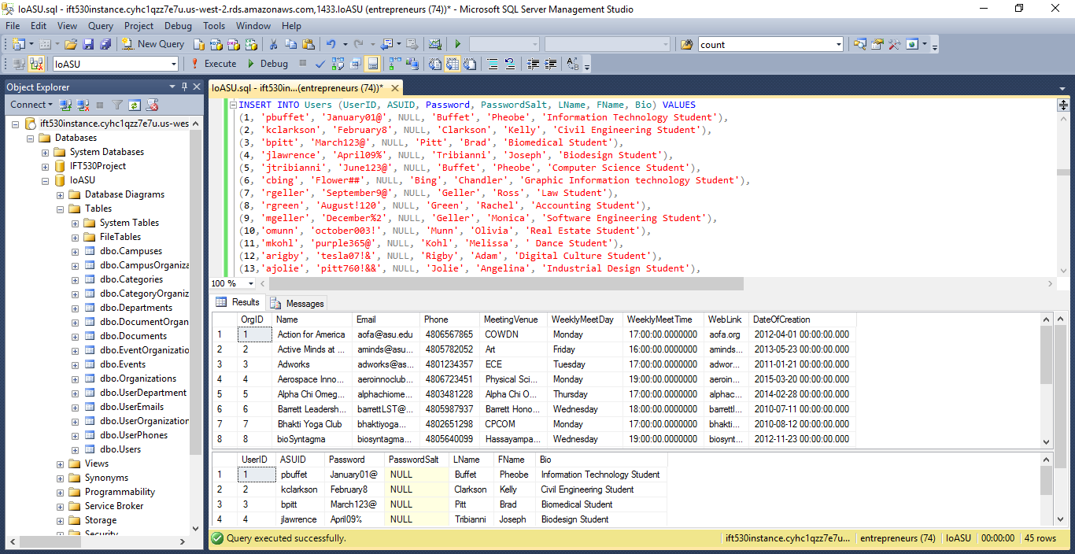

3. Views:

USE IoASU;

--View for campuses and number of organizations on each campus

GO

create view CampusOrganizationCountView as

select Campuses.CampusID,CampusName,count(*) as 'Number of organizations'

from Campuses inner join CampusOrganization

on

Campuses.CampusID=CampusOrganization.CampusID

group by Campuses.CampusID,CampusName

GO

SELECT* from CampusOrganizationCountView

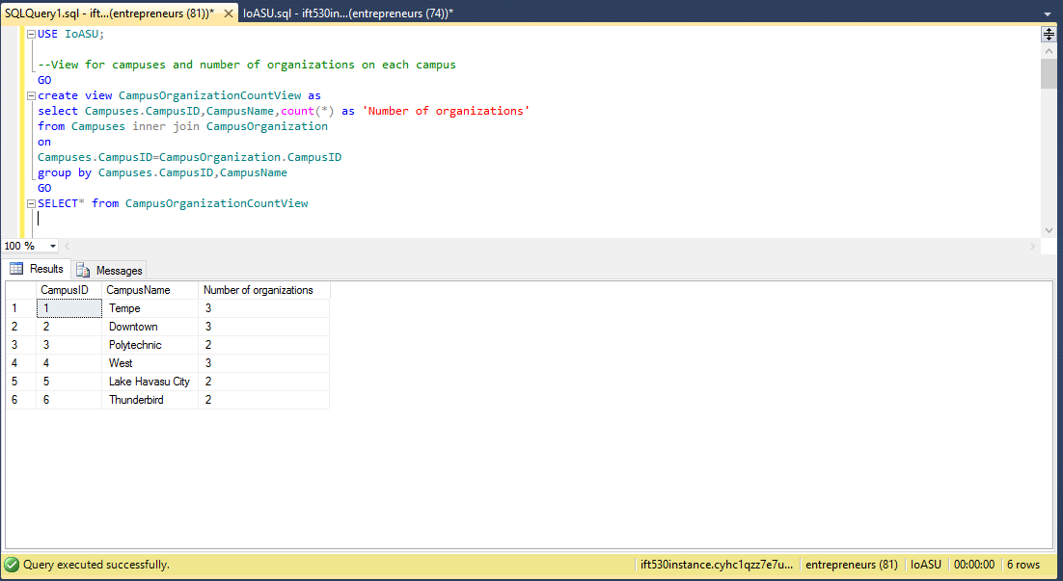

--View for categories and number of organizations

GO

create view CampusOrganizationCountView as

select Categories.CategoryID,CategoryName,count(*) as 'Number of organizations'

from Categories inner join CategoryOrganization

on

Categories.CategoryID=CategoryOrganization.CategoryID

group by Categories.CategoryID,CategoryName

GO

SELECT* from CampusOrganizationCountView

